**Supplementary Material S8.** Experimental data used to calculate the average coculture composition as a function of O2 availability and phenotype.

**Cocultures 1 and 2**

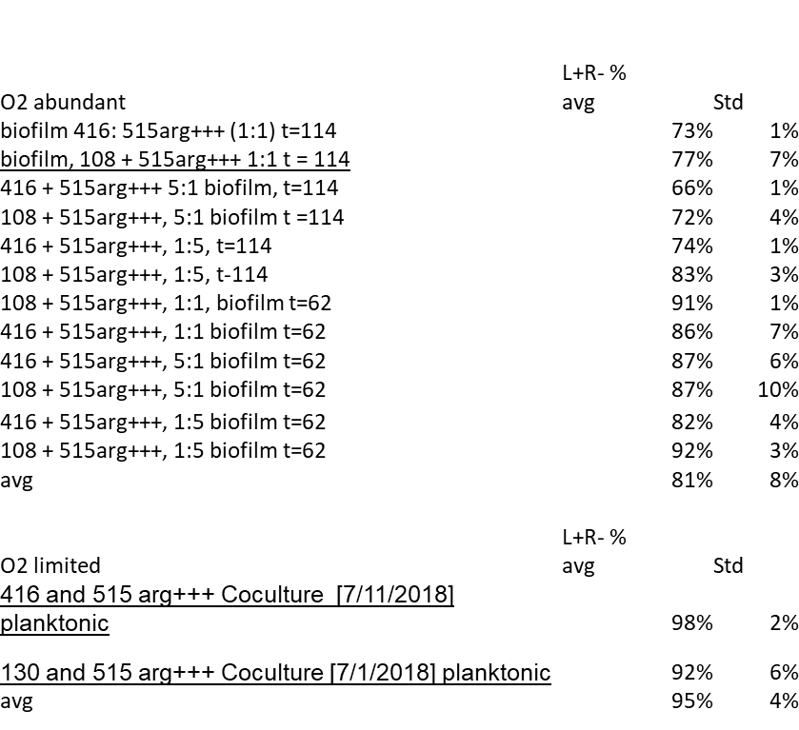

**Coculture 3, continued below**

